# **LUJAN MERCHANTS**

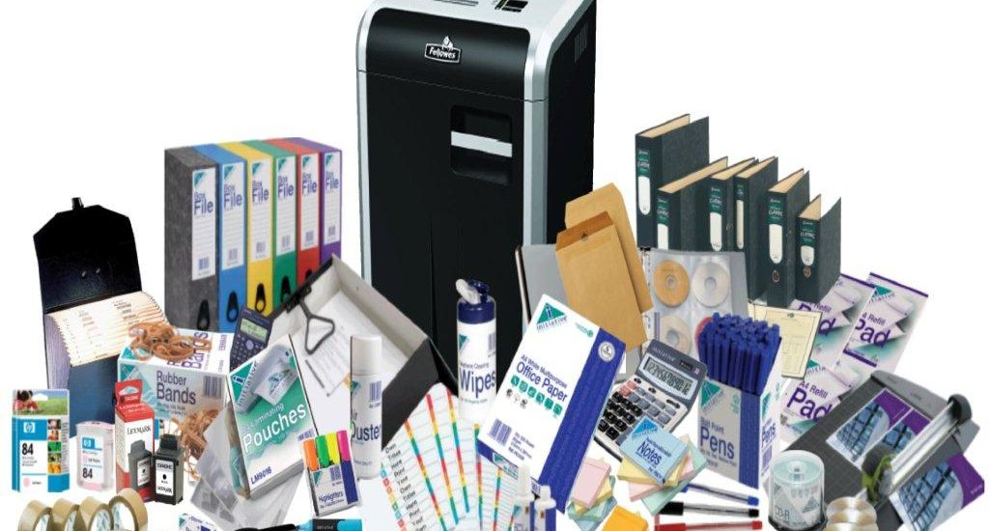

LUJAN MERCHANTS is a general supplies company specializes in the provision of cost effective products and services ranging from office stationery, computers, electronics products and accessories, supply of office automations, stationeries among others all over Kenya.

We focus on delivering high-impact solutions that incorporate customized functionality specific to the client's requirements. The combination of thorough process, comprehensive experience and expansive creative vision enables us to provide services and products that are innovative, usable and reliable.

Our Services

**Stationeries, computers & Office equipment Sell and Supply**

Stationery really covers a vast array of everyday office items. We supply all major brands and cover the whole spectrum of products including:

* Papers, Envelopes, Writing, Graphic Supplies, Desktop Accessories & Labels
* Books, Pads, Diaries, Organizers, Filing & Archival Storage
* Accounting, Personnel Files, Binders, Indices, Office Tapes & Adhesives
* Continuous Stationery, Clips & Fasteners.

**Computer Hardware and Accessories**

We have experienced IT experts to manage the sales and service for branded computers peripherals and accessories. Some of our products include the following;

* Branded Desktop & Laptops, Hard Drives, CD-ROM Drives, Printers, Cables
* Removable Drives, Cartridges, Memory, Power Supplies, Motherboards, Controller Boards,
* Tape Drives, Floppy Drives, Tape Drives, Optical Drives, Presentation Products, Multifunction Devices
* Camcorders, Graphics/Video Devices, CD-Rewritable Drives, Processors Cases, Flash Disks

**Retail Shopping & Office Automation**

LUJAN MERCHANTS’ retail shopping and office automation division is responsible for the supply, installation and design of the following:

* Multifunctional Fax machines, Printers, Copiers and Scanners
* Word Processors, Calculators & Organizers
* Telephones & Answer machines
* Shredders, Trimmers & Guillotines Plotters

With well experienced staff in hand, we confidently lead this market by giving optimum, priority to Customer Satisfaction. We are committed to efficient after-sales-service, support, and we provide Annual Maintenance (AMC) to the total satisfaction of our customers.

**Software**

We sell genuine licensed software as well as installation to computer systems.   
These software range from Operating systems such as Windows XP and Windows Vista, Antivirus, Microsoft Office and other latest application software including games and entertainment.

**Helpdesk Support**

Local Help desk Support is provided by LUJAN MERCHANTS for all the products and services we offer. Our support desk is manned by consultants with relevant industry experience who also deploy the solutions.

The Help desk is underpinned by Service Level Agreements (SLA) that are mutually agreed with the customer with regard to the response and resolution times to a query and the escalation levels. We understand the importance of mission critical applications and customers can sign into standard, gold and platinum levels of SLAs.

**Company Over view**

LUJAN MERCHANTS specializes in the provision of cost effective products and services ranging from electronics products and accessories, office automations, and stationeries among others all over Kenya.

We focus on delivering high-impact solutions that incorporate customized functionality specific to the client's requirements.   
  
The combination of thorough process, comprehensive experience and expansive creative vision enables us to provide services and products that are innovative, usable and reliable.

LUJAN MERCHANTS was established in response to the growing market demand for high quality innovative solutions at affordable prices.   
  
Our commitment to refining the development has allowed us to introduce a wide range of products as well as customized solutions that enable businesses to simplify their operations.

With business experience and an ongoing relationship with well established companies, our staffs have worked with business leading companies to acquire an in depth understanding of the latest technologies and processes.

**Our Legal status**

LUJAN MERCHANTS is e registered company and it holds a certificate of Registration No. 518987 Dated 10/07/2008 Registered by Registrar of Companies Kenya.

**Our Visions**

To become a leading company offering the best, reliable, valued added solutions to our clients.

**Our Mission**

To increase benefits and value added to Clients.

**Our Strength**

Our core competencies are spread in diverse field from electronics products, electronics accessories, software, office automations, stationeries just to mention a few.

We aim to provide highly competitive price- performance solutions and services.

We are one point solution providers of all services infrastructure and manned by a team highly skilled and dedicated professionals.

Our Values

As a company, and as individuals, we value integrity, honesty, openness, personal excellence, constructive self-criticism, continual self-improvement, and mutual respect.

**Our Team**

LUJAN MERCHANTS strives to employ personnel of skill, integrity and enthusiasm, and provide them with the opportunities to be exposed to different technological challenges.

Armed with this unique combination of strengths, we are confident that we can supply any product and services required by our customers.

Our personnel have the strong technical background and relevant work experience to meet the customers' expectations.

**Company's Key Personnel**

|  |  |
| --- | --- |
| Lilian Odwoma (General Manager) | James Maragua (Finance & Admin) |
| Lucy Were (Sales Manager) | Millicent Wanjiru (IT Specialist ) |
| Fred Aidi (Sales) | Ruth Moraa (Sales Representative) |
| Kevin Ochieng (Driver ) | James Mwangi (Sales Representative) |
| Judy Kama (Office Attendant) | Getrude Mwangi (Accounts Clerck) |

**ORGANIZATIONAL CHART**

**KEY CLIENTS**

|  |  |
| --- | --- |
| Massatech Limited | Nairobi |
| Lambo Suppliers | Nairobi |
| Eunicem Limited | Nairobi |
| Hoffina Limited | Nairobi |
| Sardinia Ventures | Nairobi |

**Contact Us**

LUJAN MERCHANTS  
Plot No 209/2362, Town House , Kaunda Street , Nairobi  
P.O Box 16993, 00100, Nairobi, Kenya.  
  
Tel/Fax: +254 788407832, 0787200094  
Email: yero7735@gmail.com